**Process Specification Forms**

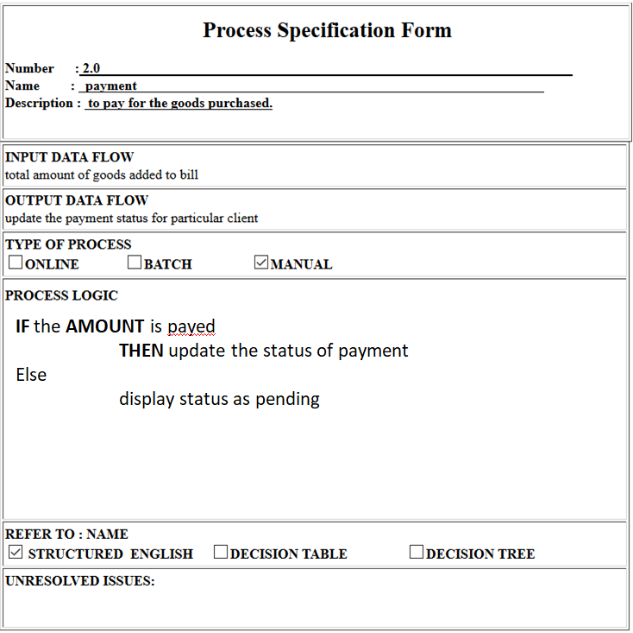

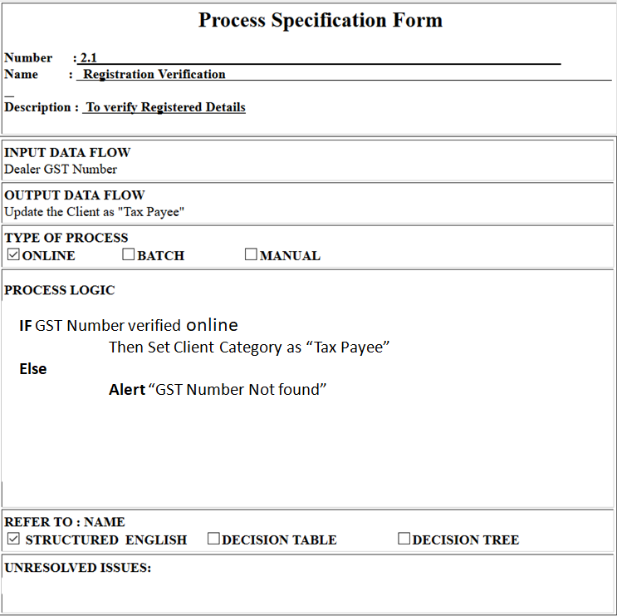

**Data Dictionary**

1. Login_Master =

UserID+

Password

1. Product_Master =

Pid+

Pname+

cid+

price_72_36+

purchase_price_72_36

1. Customer_Master=

CusID+

Cus_Name+

Cus_Phone+

Cus_Address+

Cus_Address+

Cus_Region+

1. Dealer_Master=

Dealer_ID+

Firm_Name+

Contact_Person+

Dealer_Address+

Dealer_Group+

Dealer_Region+

Gst_Number

1. Bill_Master=

Category+

invoice_date+

invoice_id +

cus_id +

cus_name+

comp_name+

product_name+

length +

width +

height+

rate +

quantity+

total discount+

net_amt

1. Payments=

Category+

Invoice_id +

Netamt +

recdamt +

balanceamt

1. Stock=

invoice_date+

invoiceid +

vendorid +

vendorname +

company +

product_name +

length +

width +

height_MM +

purch_price +

rate +

quant+

netamt +

upi +

godownS

**Input Forms**

* **Login Form**

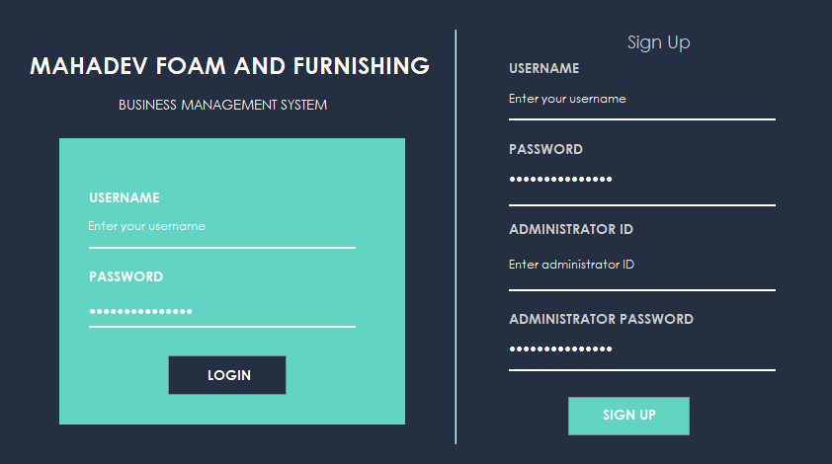

* **Dealer Details Entry Form**

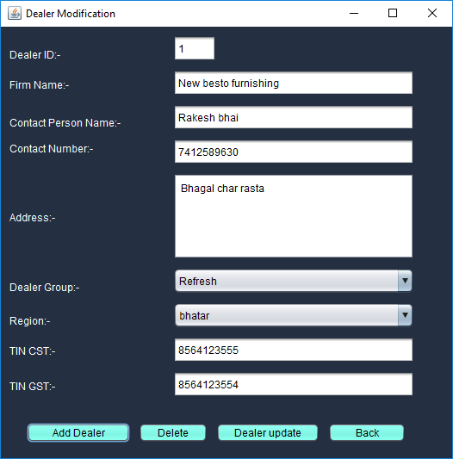

* **New Sales Invoice Entry**

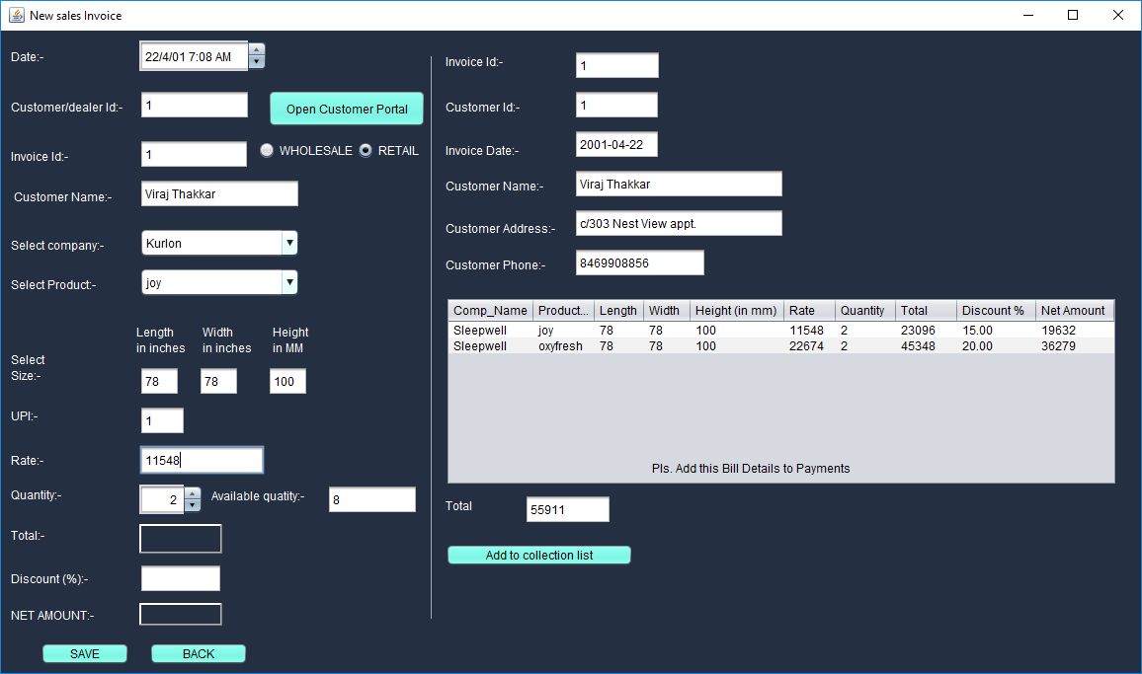

* **Task Panel**

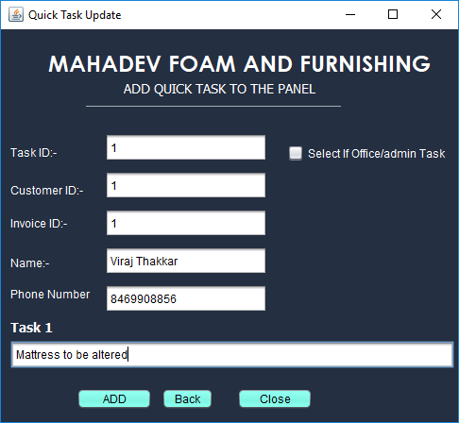

**Output Forms**

* **Dealer Database**

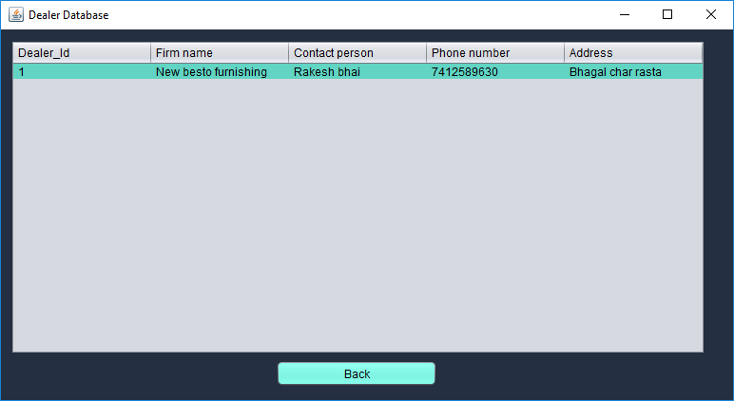

* **Stock Report**

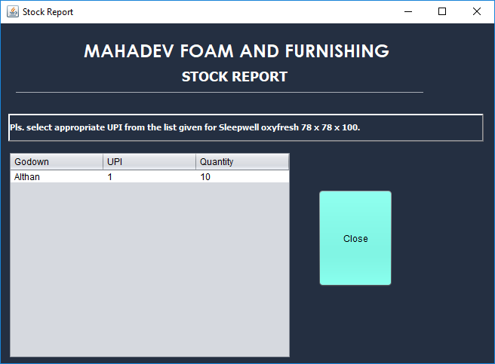

* **Yearly Bill Log**

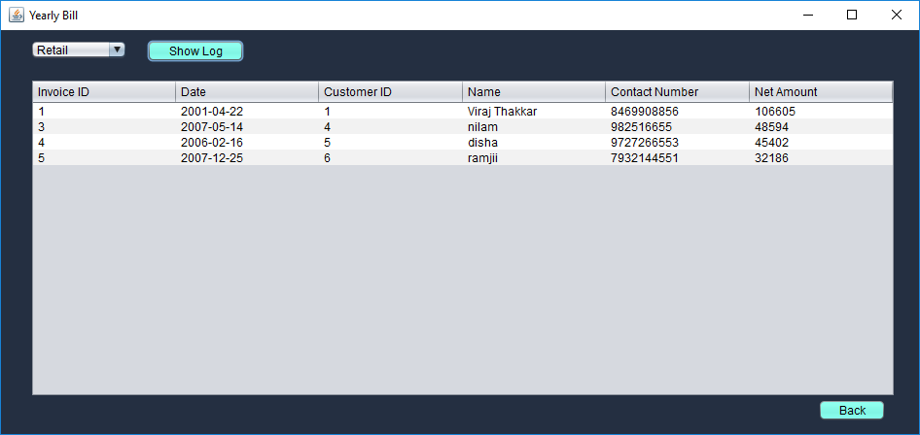

* **Statistics**

